Reading Timetables-Questions
Key Stage 3: 2003 Paper 1 Level 3-5
1.
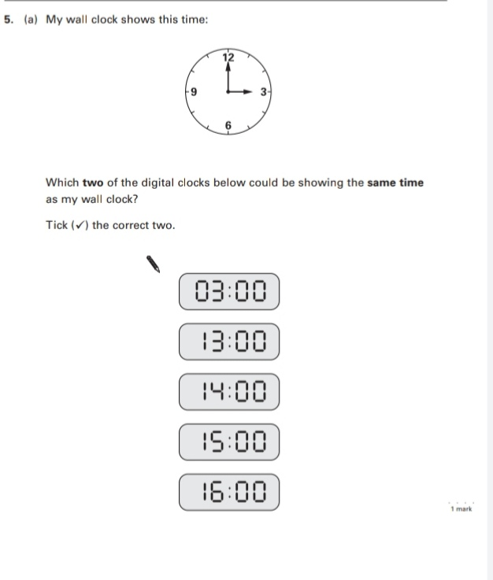
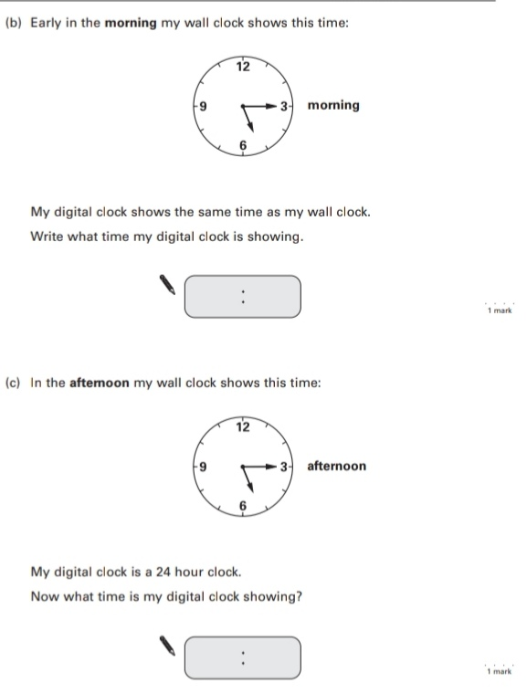
Key Stage 3: 2005 Paper 2 Level 3-5
2.
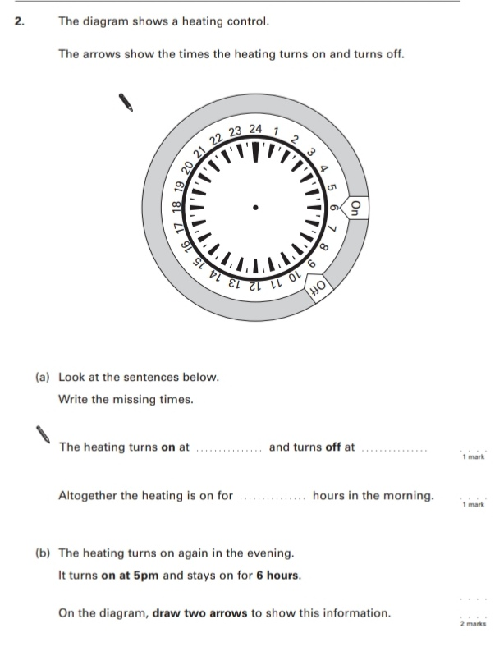
Key Stage 3: 2006 Paper 1 Level 3-5
3.
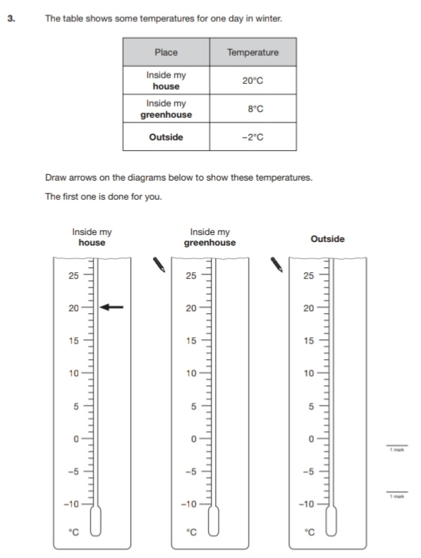
Key Stage 3: 2007 Paper 1 Level 3-5
4.
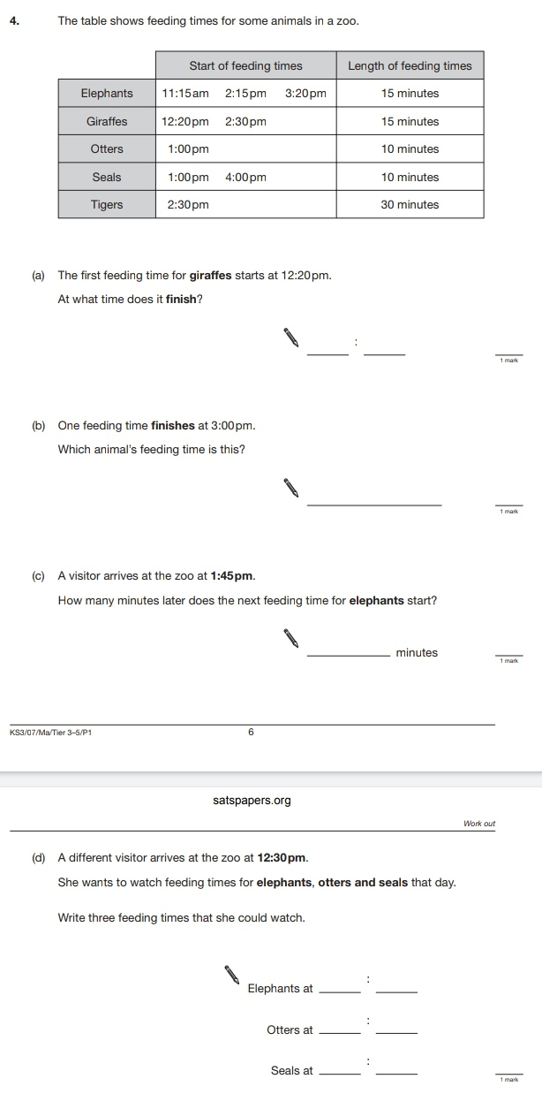
Key Stage 3: 2007 Paper 2 Level 3-5
5.
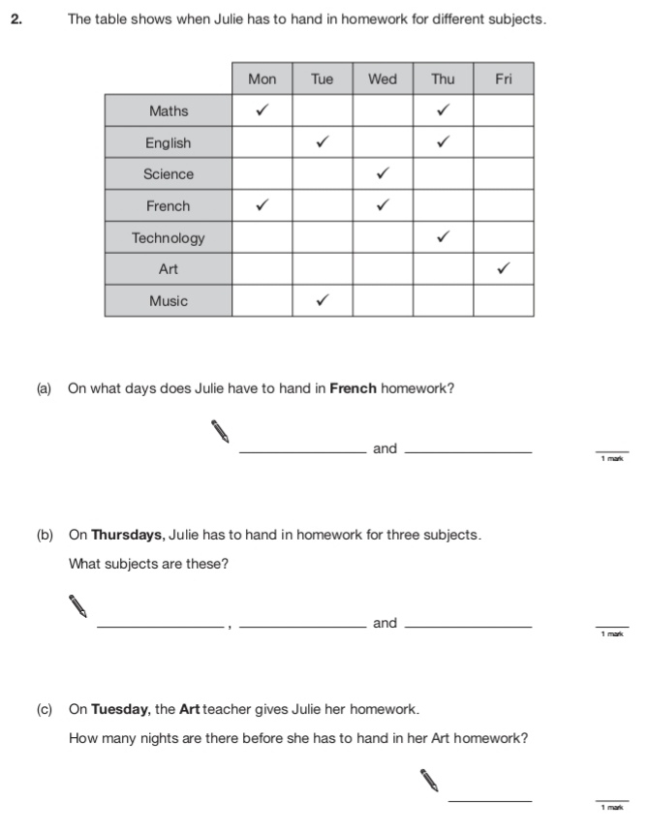
6.
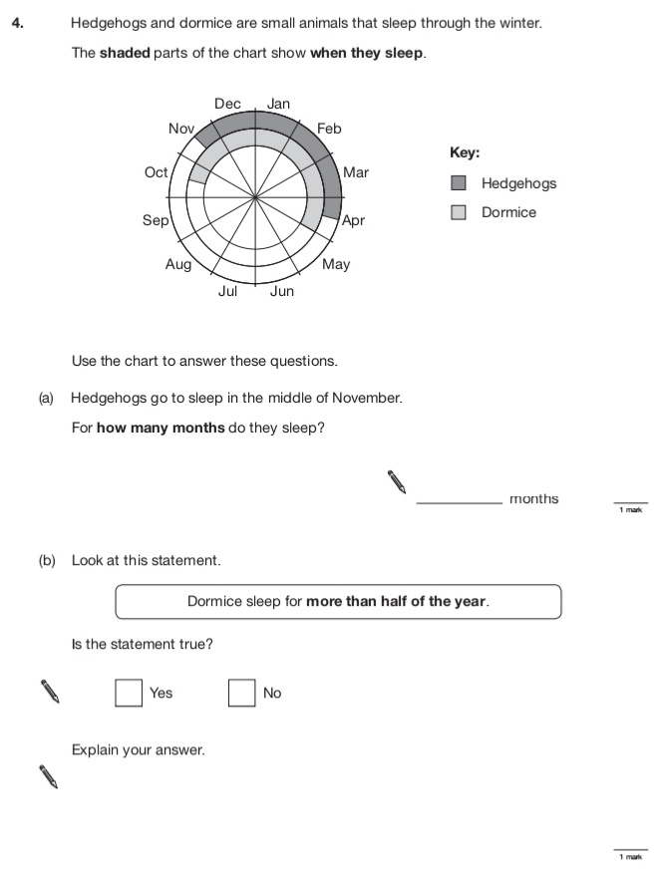
Key Stage 3: 2008 Paper 2 Level 3-5
7.
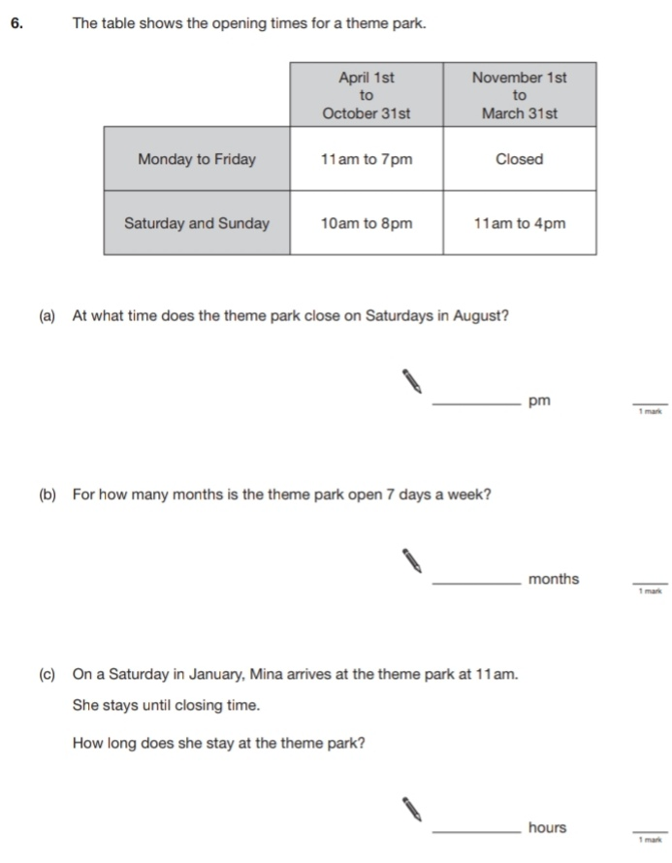
Key Stage 3: 2009 Paper 1 Level 3-5
8.
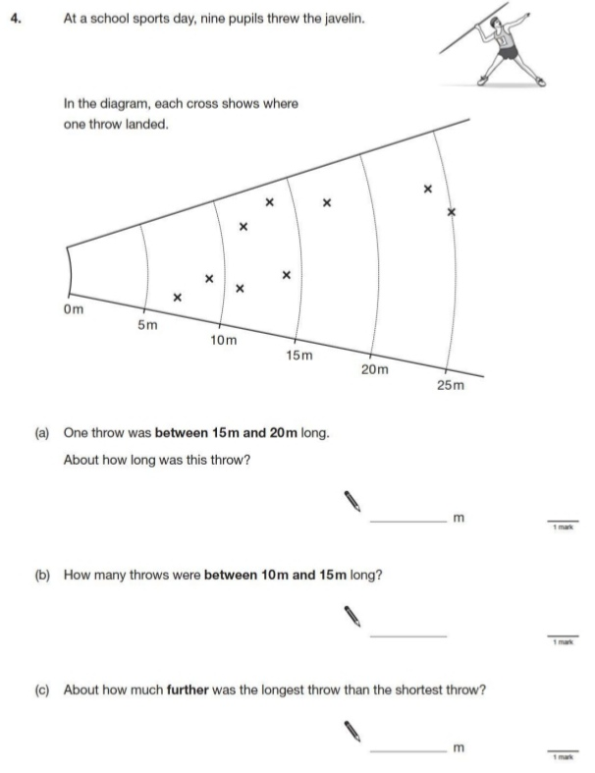
9.
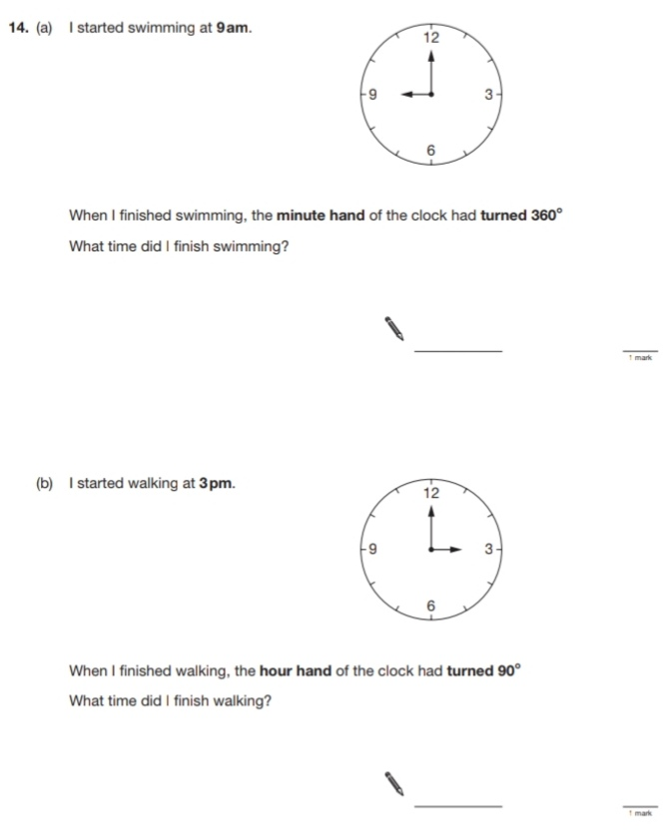
Key Stage 3: 2009 Paper 2 Level 3-5
10.
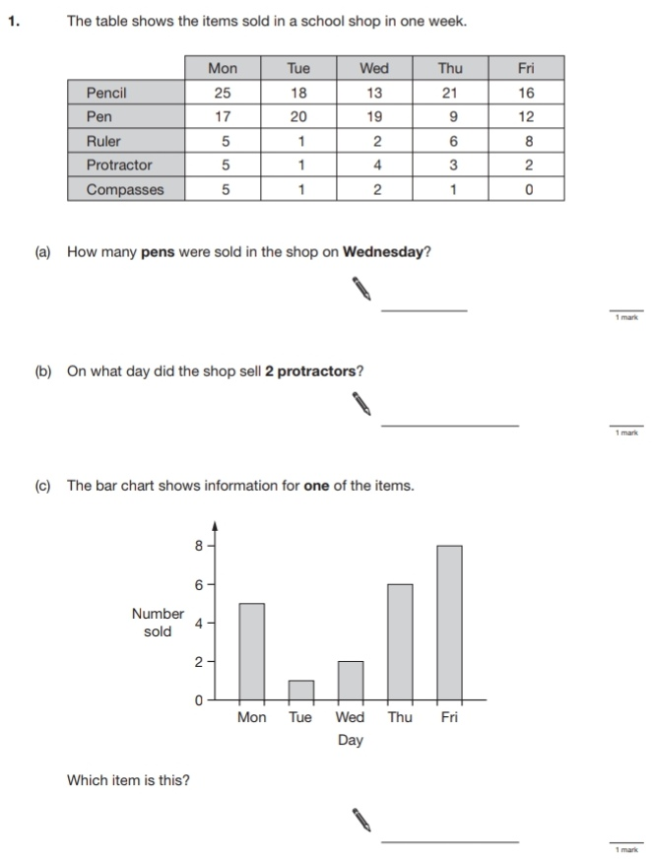
11.
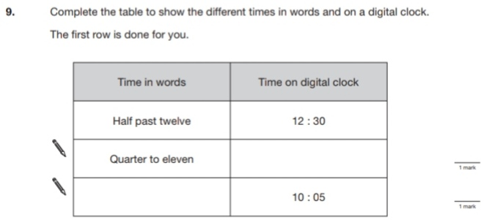
Key Stage 3: 2009 Paper 1 Level 4-6
12.
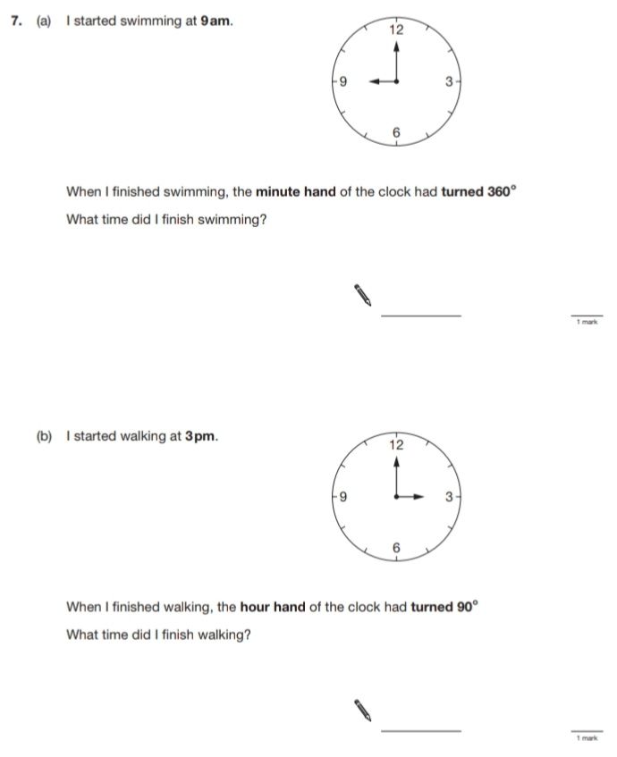
Key Stage 3: 2010 Paper 1 Level 3-5
13.
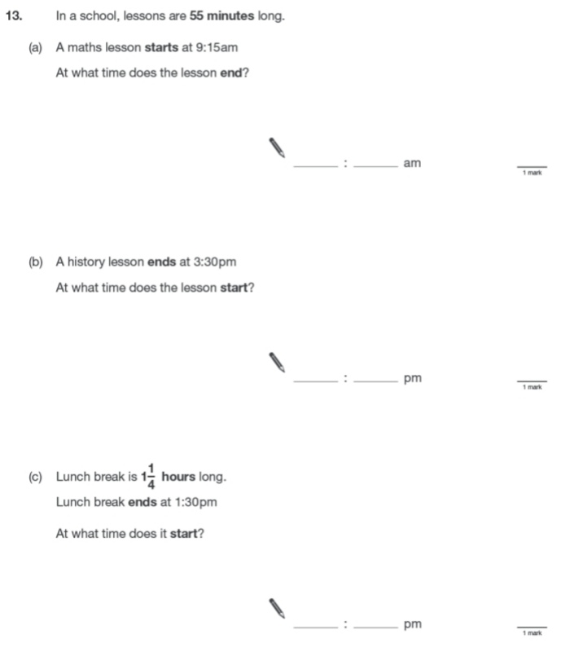
14.
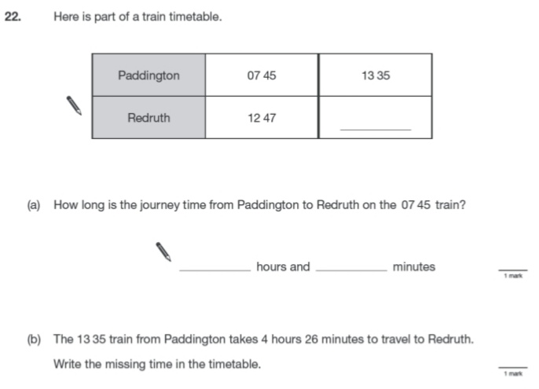
Key Stage 3: 2010 Paper 2 Level 3-5
15.
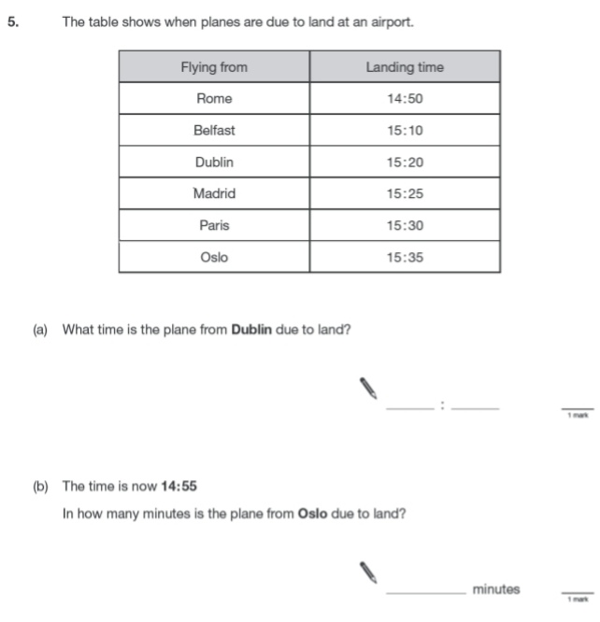
Key Stage 3: 2010 Paper 1 Level 4-6
16.
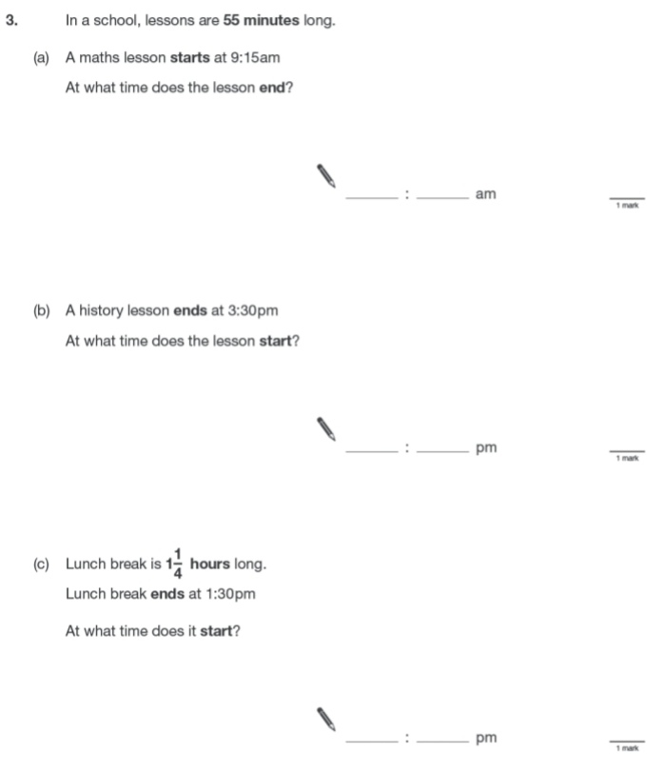
17.
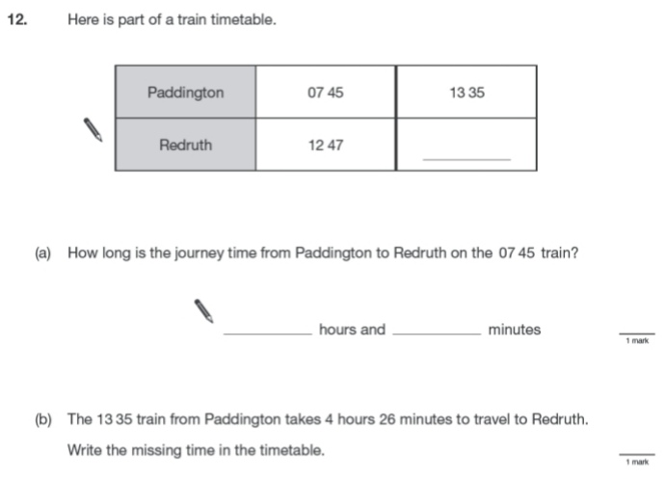
Key Stage 3: 2011 Paper 2 Level 4-6
18.
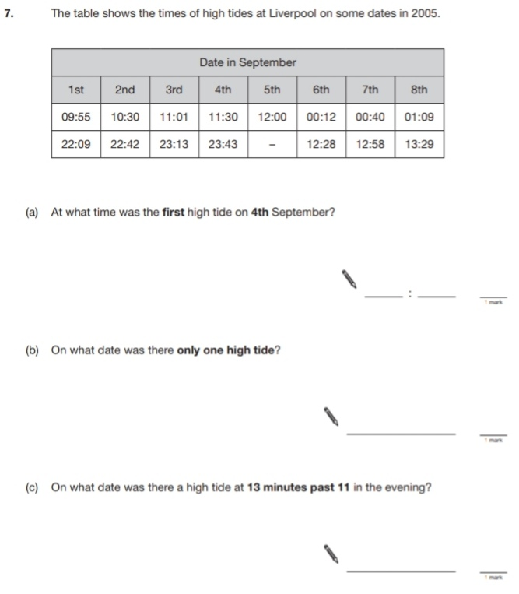
19.
